Natural Hazards Insurance Act
dispute resolution scheme
Consultation guidance

Contents:

Section one
- Why we are introducing a dispute resolution scheme 2
- The new Natural Hazards Insurance Act 2
- What we want to hear from you 2
- How to make a submission 3

Section two
- Description of the new scheme to resolve claim disputes 4

Section one

We’re consulting on a new dispute resolution scheme
We’re asking for your feedback on an independent dispute resolution scheme for natural hazards insurance claims. This will support insured homeowners to resolve disputes about claims for damage from natural hazard events that happen on or after 1 July 2024.

Why we are introducing a dispute resolution scheme
New Zealand homeowners with a current home insurance policy that includes fire insurance are covered by Toka Tū Ake EQC (the Commission) for natural hazard damage to their home and some of their residential land. You can read more about this cover on our website.

The new Natural Hazards Insurance (NHI) Act, which takes effect on 1 July 2024, requires the Commission to be a member of an external dispute resolution scheme.

The Commission and insurance providers have internal complaints processes available to homeowners, in line with best practice. It is important that homeowners also have access to trusted, external services for disputes that are not resolved internally.

When a homeowner has a dispute about a decision on their natural hazard claim, the following options are available:
- Complain to the Commission/insurer, who will work through their internal process
- Refer the dispute to the new, external dispute resolution scheme
- Take the dispute to court
- Raise a complaint with the Ombudsman.

The new, external dispute resolution scheme will offer insured homeowners an easy-to-navigate option for resolving disputes that have not been resolved internally. It will consider disputes about claim validity and the extent of the settlement, for example the cost to repair damage. The scheme will be independent and support fair and timely resolution of disputes for homeowners.

There is more detail about how the scheme will work in Section two.

The Natural Hazards Insurance Act
The NHI Act will replace the Earthquake Commission (EQC) Act 1993 on 1 July 2024. The new Act addresses the lessons learnt from the Canterbury earthquake sequence, the Kaikōura earthquake, and other natural hazard events, as well as the Public Inquiry into the Earthquake Commission completed in 2020.

The NHI Act will introduce several improvements for homeowners, including:
- a Code of Insured Persons’ Rights
- an independent review process and complaints process that support the Code
- a dispute resolution scheme.

Under the NHI Act, the Earthquake Commission will be renamed Toka Tū Ake - Natural Hazards Commission. We will continue to provide natural hazards insurance for residential properties under the new Act.

Existing services are available for disputes about claims involving damage that happened before 1 July 2024. These are dealt with under the EQC Act. Read more about existing ways to make a complaint and resolve disputes.

What we want to hear from you
We want to make sure the dispute resolution scheme will work well for insured homeowners so we are asking for your feedback on the scheme rules and how it will operate.

How to make a submission
Submissions close at 5pm, Wednesday 6 March 2024.

We welcome feedback in writing, online or over the phone.

You can:

- Fill in the online form
- Fill in the MS Word feedback form and email it to publicconsultation@eqc.govt.nz or post your submission to Attn: Dispute resolution consultation, PO Box 790, Wellington 6140
- Call 0800 326 243 to make a verbal submission – a member of our team will talk you through the feedback form and fill it out on your behalf.

You do not need to respond to all of the questions. You can make your submission anonymously.

We look forward to receiving your feedback. Please make only one submission.

Please note: we will not be replying to individual submissions. If you have any other questions or concerns, visit our website, or call the contact centre on 0800 326 243.

Submissions are public information
We may release any part of your feedback under the Official Information Act 1982 if someone requests it. Please consider this when filling out your submission.

We will hold and use any personal information you provide in line with the Privacy Act 2020. We will only use your information for the purpose of developing the dispute resolution scheme and related activities. You have the right to request access to, or to correct, any personal information you provide. Please only share your own information or information that you have permission to share on someone else's behalf. We’ll only contact you if you indicate that you want to be advised when the summary of feedback is available.

Next steps
We’ll consider all submissions made by 5 p.m. Wednesday 6 March 2024. We will release a written summary outlining how consultation feedback has contributed to the development of the dispute resolution scheme.

Section two

Description of the external dispute resolution scheme
The external dispute resolution scheme is for resolving disputes about:
- whether the claim is valid, for example whether or not damage has been caused by a natural hazard event, such as an earthquake or landslide, or
- the extent of the claim settlement, for example the cost to repair the damage.

Fair Way Resolution (Fair Way) has been selected as the preferred provider to deliver the external dispute resolution scheme, subject to contractual agreement and Board approval. Fair Way has more than 20 years’ experience in providing dispute resolution services.

We will cover the cost of administering the external scheme and homeowners will not be charged to use it. Homeowners may choose to engage engineering, building or legal professionals to support their claim, which would incur costs that they’ll have to cover.

The external dispute resolution process is described below and in the flow diagram.

Referral to dispute resolution scheme
The insured homeowner will be notified when a decision has been made on a claim for natural hazard damage. If the homeowner disagrees with the decision and wishes to dispute it,
they can make a complaint with their insurer and the insurer will try to resolve the complaint internally. Read more about making a complaint. The homeowner will also have the option to contact the external provider Fair Way to refer the dispute.

Mediation
The external dispute resolution scheme provider will offer mediation services and appoint an independent and impartial mediator. The mediator will offer each side guidance to prepare for a confidential process in which the mediator facilitates discussion between parties to help resolve the dispute.

Agreement
Both sides may choose to reach an agreement that is binding.

Adjudication
If there is no mediation or the mediation has not resulted in agreement, adjudication will be available to the homeowner. The external scheme provider will appoint an independent person (adjudicator) to consider the dispute and make a decision. Each side will be offered guidance to prepare for adjudication.

Decision
The adjudicator will make a decision based on the facts and evidence provided by the parties involved. An adjudicator will have the power to order the Commission to reimburse the homeowner for certain costs.

The outcome of adjudication will be legally binding and must be followed by all parties.

Appeal
If either side is unhappy with the outcome, they may appeal the decision to an appropriate court.

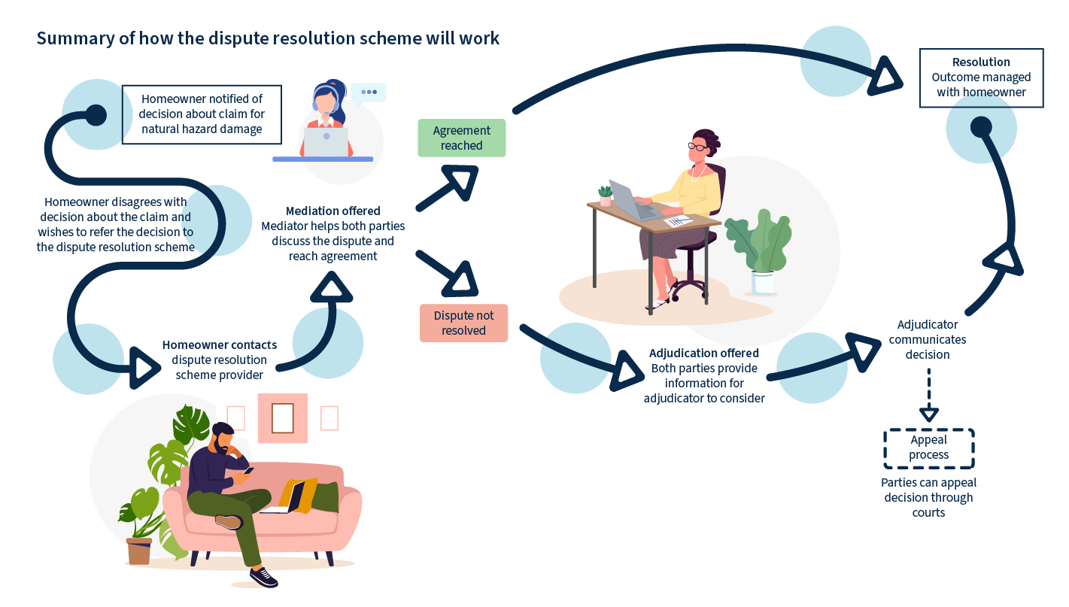

Dispute resolution scheme will meet the requirements of the NHI Act
The scheme will be delivered using best practice principles for external dispute resolution, as set out in the NHI Act. It must be:

- Accessible
- Independent
- Fair
- Efficient
- Effective
- Accountable.

Accessible
This means the external scheme will be easy for homeowners to find and use. For example:
- The Commission (or our agent) will tell a homeowner when and how a decision can be disputed through the scheme.
- The Commission is responsible for bearing the costs of administering the external scheme.
- Homeowners will not be charged for using the external dispute resolution scheme, but may incur some costs they’ll have to cover, for example the cost of a builder or estimator’s advice. The Commission can be ordered to cover some of the homeowner’s costs.
- A homeowner’s circumstances or needs will be taken into account and provided for as appropriate, for example through language interpreters, and disability or wellbeing support.

Independent and fair
This means the external scheme will be able to support resolutions in an unbiased way. For example:
- Independent mediators will help the parties reach agreement, and qualified adjudicators will make decisions based on the information provided and relevant law.
- Assistance will be offered to both parties to participate in the process. For example, the scheme provider will ensure that homeowners understand what to expect through the process, what they need to do and time frames.

Efficient and effective
This means the external scheme will support quality decisions and timely resolution. For example:
- The scheme provider is experienced in providing dispute resolution services and is focused on efficiency and effectiveness.
- The scheme provider will be able to respond to disputes in a timely way. The scheme provider will communicate expected timeframes to homeowners.
- Mediators and adjudicators will have accreditation from a professional dispute resolution organisation. Mediators and adjudicators will have experience relevant to the dispute.
- Any dispute regarding private insurance cover, linked to the natural hazard insurance claim, may be included in the resolution of the dispute.

Accountable
This means that the external scheme will be monitored for quality. For example:
- The scheme provider will be required to provide regular reports and the dispute resolution service will undergo periodic independent review.
- The scheme provider will collect information for monitoring purposes and to improve its performance.
- Anonymised summaries of cases will be published online.

